Upper Deverills Parish Council

9 Beech Grove, Warminster, Wiltshire, BA12 0AB Tel: 01985 213436
Chairman: Miss Louise Stratton Clerk Mrs Sarah Jeffries MILCM

All Parish Council Meetings are open to the Public and Press
Tuesday 24th November 2015 6.00pm

To All Members of the Upper Deverills Parish Council
Dear Councillor,

You are summoned to an extraordinary meeting of the Upper Deverills Parish Council, at Kingston Deverill Village Hall on Wednesday 24th November 2015 6.00pm. The meeting will consider the items set out below.
Before the meeting there will be a public session to enable the people of the Upper Deverills to ask questions of, and make comments, regarding the Parish Council. Questions not answered at this meeting will be answered in writing to the person asking the question, or may appear as an agenda item for the next meeting. Members of the public are asked to restrict their comments, and/or questions to three minutes.
Sarah Jeffries MILCM 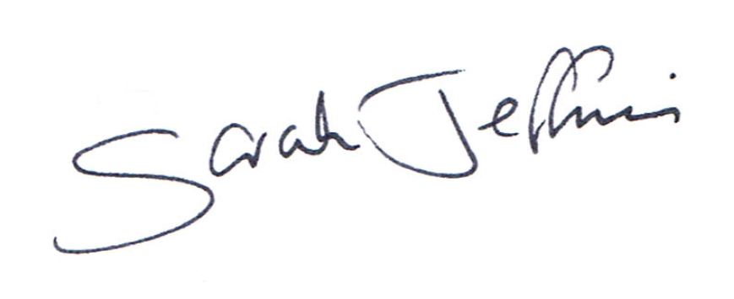 18th November 2015
Parish Clerk

6.30pm Public Question Time
This section (at the Chairman’s discretion may last up to 15 minutes) is not part of the formal meeting of the Council and minutes will not be produced.

1. Acceptance of apologies for absence
Schedule 12 of the Local Government Act 1972 requires a record to be kept of the members present and that this record form part of the minutes of the meeting. Members who cannot attend a meeting should tender apologies to the Parish Clerk as it is usual for the grounds upon which apologies are tendered also to be recorded. Under Section 85(1) of the Local Government Act1972, members present must decide whether the reason(s) for a member's absence are accepted.

2. Chairman’s announcements

3. Dispensations
Council is asked to discuss any written requests for dispensation the Clerk may have received from Councillors. Council is asked to resolve the dispensations if required.

4. Declarations of interest, members to declare any interest they may have in agenda items that accord with the requirements of the relevant authorities (Disclosable Pecuniary Interests) Regulation 2012 (SI 2012/1464) (NB this does not preclude any later declarations)

5. Exclusion of the Press and Public Standing Order #1c The Parish Council may exercise their right to exclude the public and press by resolution from a closed meeting due to the confidential nature to be discussed pursuant to section 1(2) of the Public Bodies (Admission to Meetings) Act 1960.

6. To receive and sign the minutes of the Full Council meeting held on the 8th July 2015 and planning meeting held on the 10th October 2015 (Previously circulated) LGA 1972 Sch 12 para 41(1)

7. Co-option
Council is asked to witness the signing of the Co-option papers of Mrs Bridget Beattie.

8. Correspondence
Council is asked to discuss the recent correspondence received by the clerk regarding planning application 15/10513/FUL Proposal: Demolition of barn and erection of a dwelling (Resubmission of 15/06445/FUL) Location: Barn adjacent to, 81 Barn View, Hindon Road, Monkton Deverill, Wiltshire, BA12 7EX. Minute number 15/097.

9. Parish Clerks Delegated Powers the Clerk will give Council details of any matters dealt with under her delegated powers since the last meeting of Council. LGA 1972 s101

10. Notice of items to be taken into consideration at the next meeting.
Councillors are asked to highlight items.

11. Items for Parish Newsletter & Notice Boards
Councillors are asked to inform the Clerk.

12. Date of the next meeting The Council is asked to note that Wednesday 20th January 2016 is the date of the next Full Council meeting.

Council are asked to note that in the exercise of their functions they must take note of the following: Equal opportunities (race, gender, sexual orientation, marital status and any disability); Crime and Disorder, Health and Safety and Human Rights. Any person who may find difficulty in access to the meeting through disability is asked to advise the Clerk (07540 611906) or 01985 213436 email (upperdeverills@virginmedia.com) at least 24 hours before the meeting so that every effort may be made to provide access

Chairman: Louise Stratton Slades Cottage Kingston Deverill, Warminster Wiltshire BA12 7HE
Clerk: Mrs Sarah Jeffries MILCM 9 Beech Grove Warminster Wiltshire BA12 0AB 01985213436

